"Discover How Abdul Made $4,053 In Less Than A Month From CPA Marketing And How You Can Duplicate His Unique System and Make A Minimum Of $100 - $500 Per Day Using This CPA Secret Code Guide."
WRITTEN BY: YAKUB ABDULAZEEZ

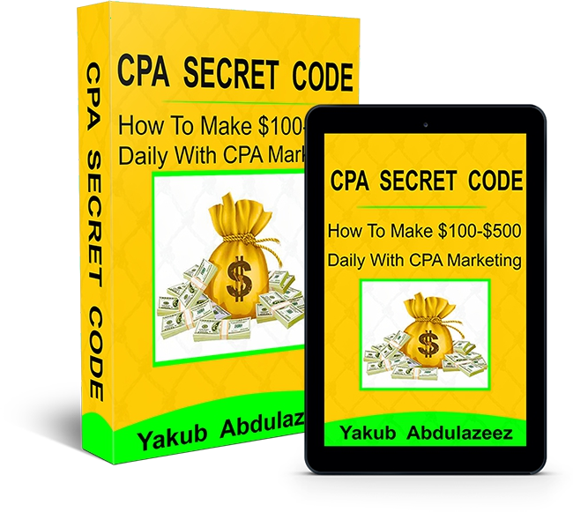

You Have My Permission To Share

This is a FREE report and you have my permission to share it with your contacts. Feel free to post it online, share it on social media, add it to your blog, or email it to your friends.
If you are looking for a way to make money online with CPA Marketing, I guarantee this will be the last book you will read on how to make a decent income online with CPA Marketing Irrespective of where you live in the world. Because, in this book, Abdul will break down everything you need to know about CPA Marketing.
With that said, If you have been struggling to make money online, Reading this book today is one of the best decisions you have ever made.
In this report, I'm going to reveal to you the simple method to make a minimum of $100 - $500 per day with CPA marking using this CPA Secret Code Guide.
In case you don't know Abdul or if this is the first time of hearing his name or reading his e-book.

Yakub Abdulazeez is a professional CPA Marketer who has been making money with CPA marketing for years now.
Not only has he been making money, so far he has taught over 250 students his unique simple system to make money with CPA Marketing from the comfort of their home.
You see, It doesn't matter if you have tried to make money online before and you did not succeed or you have bought several courses online before and it doesn't work for you.
The method I am going to show you today is guaranteed to make you at least $100 per day using your computer to promote CPA offers if you follow the entire secret revealed in this training.
I said $100 per day because that is the minimum amount of money my students and I are making everyday using the CPA Secret Code Guide.

Although, There is no limit to what you can earn Daily, Weekly and Monthly.
Imagine making $100 per day in this hard economy where everything is very expensive. If you convert that amount to your local currency you will discover this is not a joke.
I know you may be thinking how possible this is. Don’t worry if you read this book from the beginning to the end, you will not only see proof of earnings but you will also learn how to copy and paste a unique simple system and start getting a result right away

Why You Should Take This Guide Seriously
I have been looking for a means of earning legitimate money online. When it comes to the online space I was a total novice not before I came across this same Ebook that taught me how to make money in dollars from the comfort of my home. I have always wished to earn money in dollars to enable me to live a more fulfilling life. I bought many courses that promised me making money online but they all happened to be a total waste of time and resources. Within a short period of starting CPA marketing I became highly successful.
That is why I am encouraged to share this ebook with anyone who is looking for a way to make money online.

If myself and Abdul can do it you can do it too.
Below is over $4,000 commission earned by Abdul from CPA marketing for you to know that this is not a joke.

Here is the screenshot of over $4,000 earned by Abdul from CPA Marketing:

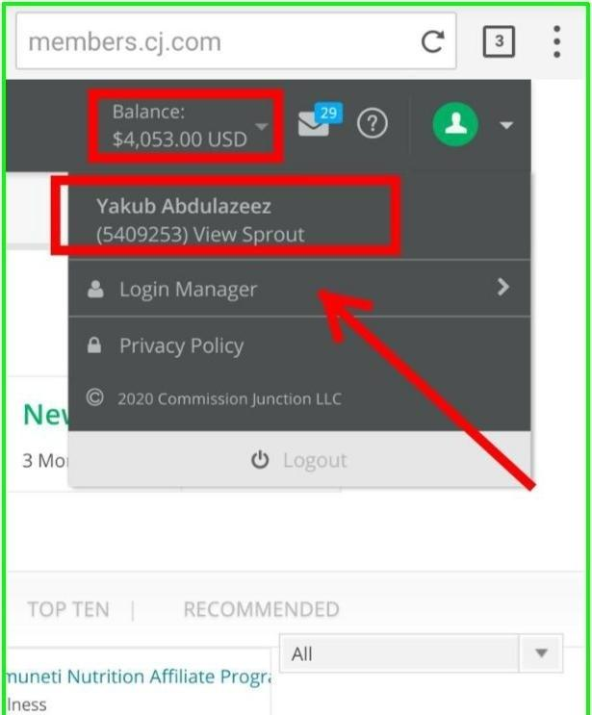
Yeah, He Earned $4,003 Commission From cj.com

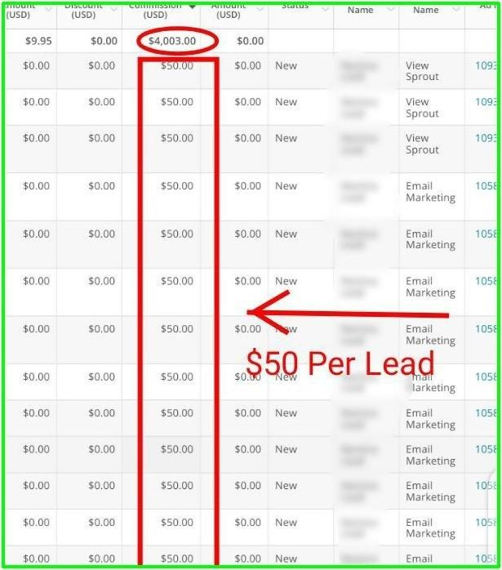

And the amazing part is that he was able to make this money in less than a month by promoting one of the top telecommunication company in the United States that pays $50 per lead for each customer that he brings to their website to fill a simple registration form.

Also, Look At What Other People Are Saying About This Guide:
FROM: Idorenyi Christopher. He Made $320 In 2 Days
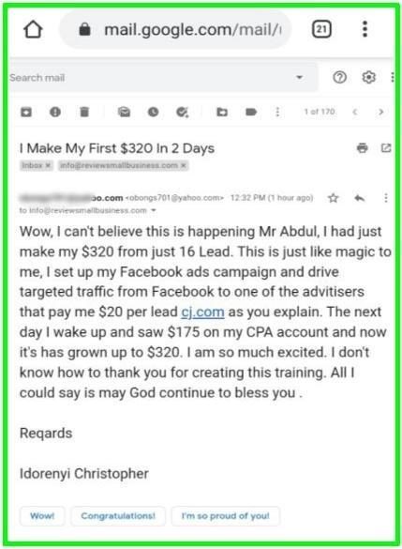

FROM: Olagoke Oluwakemi. She Made Her $200

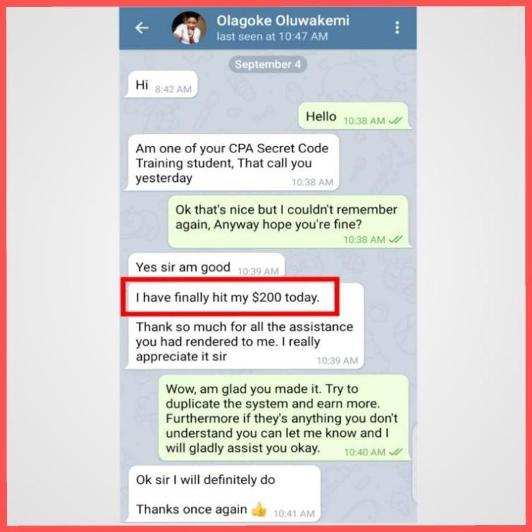
FROM: Steve Leonard. He Made His First $150

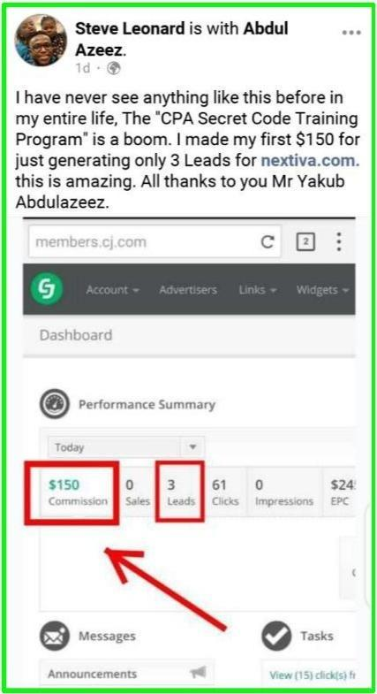

This is why you should take this guide seriously if you want to make money online with CPA marketing business.
Today, you will learn everything you need to know to earn your first $500 in the next 7 days starting from today if you take the necessary action after reading this book.
With that said, let's quickly look at what CPA Marketing is.

What Is CPA Marketing
CPA Marketing is all about getting a potential customer to fill a form or any other specific action and you get paid.
That is why I recommend CPA Marketing. It doesn’t matter even if you have not engaged in any online business before, as long as you have a computer with good internet connection, You’re good to go.

Here Are Other Advantages That Make CPA Marketing The Best!

Let's say you’re running ads on Facebook and your daily budget is $10. Let assume that with the $10 daily budget you are getting 150 leads per day. In CPA Marketing, especially Pay Per Lead program, If you get 150 leads per day, there is a possibility that out of the 150 leads, 80% of the leads may end up filling a form on your advertiser landing page and once the form is filled, you will get paid for that action taken by your customers.
You don’t even have to wait till people buy something through your link before you make money unlike the normal affiliate marketing model where you have to go through a lot of stress in order to make a sale before money can be made.
That is why CPA Marketing is highly profitable than every other online business you might have heard of.
Let me quickly show you one of my partner's companies that pays me $30 per lead. It's a US company Called Curadeb.com.

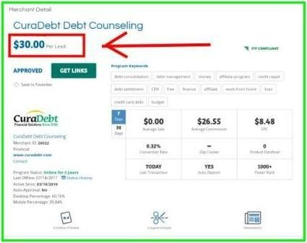
Now look at this company. Once you bring a customer to this company website to fill a simple form like the one showing below, you will earn a $30 commission instantly.
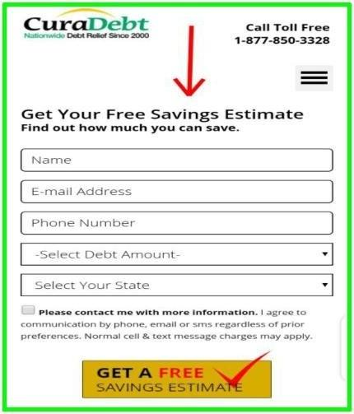

All they have to do is to enter their Name, Email address, Phone Number, Amount of Debt, State, and click on Submit Free Saving Estimate. Once that is done, You will earn $30 immediately.
Imagine if you can generate only 5 lead for this company in one day, that is
$150 commission for you and my other students and I sometimes generate up to 15 to 20 qualified leads per day using the CPA Secret Code Guide.
Let's look at another Company called Onpay.com. Onpay is one of the top payroll companies in the United States. They pay me
$40 Per Free Trial, that means if I bring a potential customer to their website to register for their 30 days free trial, I will be paid $40 Immediately. My customers don't even have to buy anything before my commission will be credited into my bank account.

All they have to do is to register for the 30 days free trial.
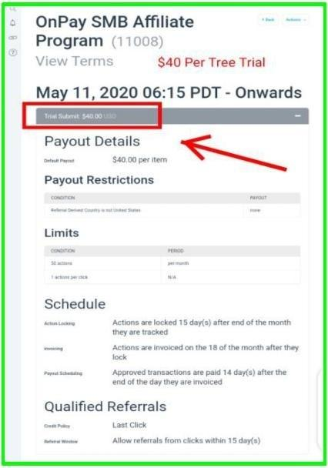

Also, Amazon Business, they pay 25 GBP per Lead. Just for you to bring someone to their website and fill their online registration form.

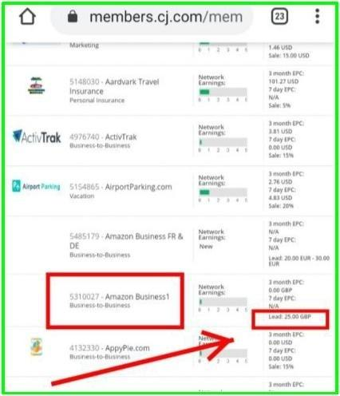

You see, there are hundreds and thousands of companies on the internet that are ready to pay you to generate high qualified leads for their company. And you don't even have to wait till your customer buys something before you earn a commission.
This is incredible. I'm very sure you will say I haven’t seen anything like this before
Well, you are not alone. The same happened to me when I was new to the world of CPA Marketing some years back.
That is why I have decided to share this Abdul simple to follow training which will work you through the step by step process on how to start making money from CPA Marketing even if you have not done any online business before.

Click Here To Access The Training Now

Inside this training, you're going to learn the Secret of how to bank a minimum of $100 to $600 per day from the comfort of our home without having to sell anything online.

You Can See The Proof Below:

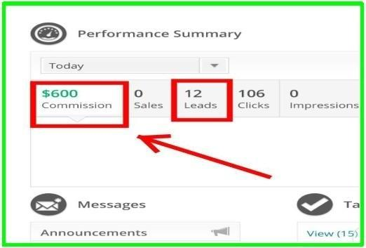

That is $600 per day from 12 leads generated for one of my partner's companies that pay me $50 per lead.
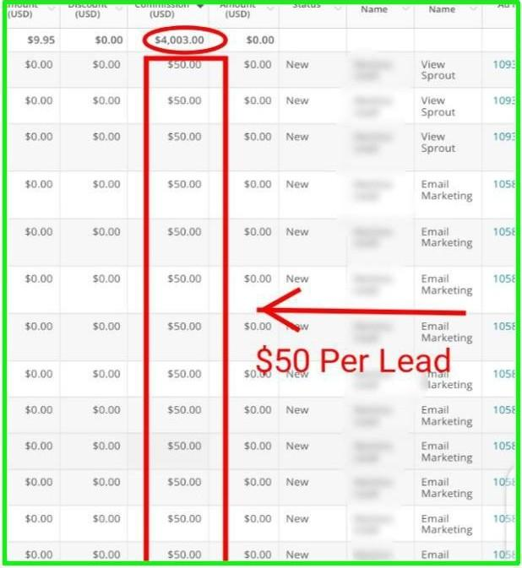

Ever since I discovered this secret my life has never remained the same.
Today I am not a billionaire, but I earned something substantial enough for me to quit my job, rent a modest apartment, have a car and live the kind of life that I have always desired.

Imagine earning $600 in a day in an African country where money is very hard to make.

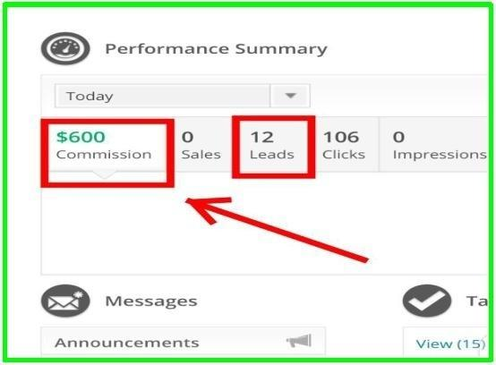

Here I Made $350 Commission In One Day:

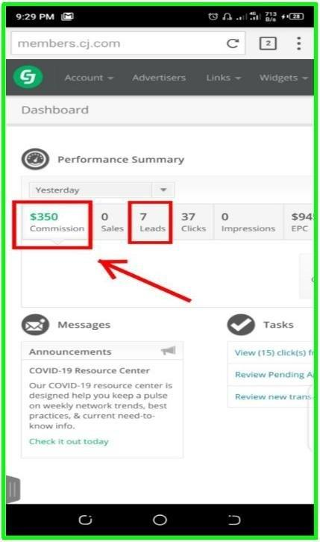

I Made $450 Commission In One day:

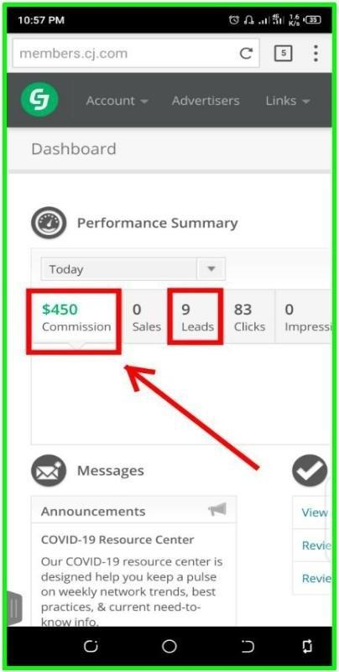

I made a total of $4,053 commission in less than a
month.

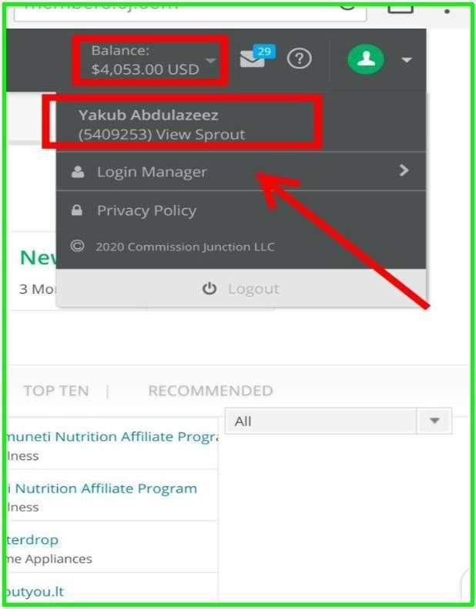

This is amazing!
Am very sure you can't wait to learn how to get this type of result.
If you are interested, there is nothing to worry about as Abdul had already put together a simple to follow step by step training to work you through the whole process and start making money with CPA marketing

Here Is What You're Going To Learn Inside The Training Program:
You will learn everything: You need to know, step-by- step, to start making money with CPA Marketing irrespective of where you live in the world.
You will learn: how to get approved to many CPA networks and how to apply for offers and be accepted.
You will learn: how to create the best landing page that will convert for CPA offers.
Abdul will reveal: to you the insane traffic strategy that he is using to make up to $500+ per day.

Click Here To Access The Online Training Now!
You can access the CPA Secret Code Training program by copy and past the link below in your browser: https://viewsprout.com/cpa-secret-code
or Click Here to Access The Training Now!

Note: This training is only available for a limited period of time. Once it reaches the maximum number of students that are to be trained Abdul may revoke new registration to this training until the current batch can stand on their own and begin to make money.
I am very sure you will like to be among the first students that will make their first $500 in the next 7 days Using the CPA Secret Code system.
You can access the CPA Secret Code Training program by copy and past the link below in your browser: https://viewsprout.com/cpa-secret-code
or Click Here to Access The Training Now!

See you on the other side
Regards
[Your Name]

PS: In case you have any questions to ask you can easily reach out to me via my whatsapp and I will reply you as soon as possible.
Whatsapp Number:

